SOUTHLAKE PERENNIAL GARDEN SOCIETY
BOARD MEETING MINUTES
OCTOBER 9, 2024
Southlake Perennial Garden Society
October Meeting Notes
October 8, 2025
Location: Darla Reeds House
Members Present- 16 Members, 1 Guest- Lori, (Darla’s Friend)
Meeting Commenced at 10:20 am

President’s Report: Darla welcomed everyone and recognized the October Birthdays- Ginger Jones, Nancy Searl, Nancy Hunter and Debbie Barnett

Treasury Report: Marybeth shared the Sept Financials
Key Highlights:
Total Ending balance: $24,654.04
SLGT Reserve- $17,503.06 and General Fund- $7,150.78

Income from Dues- 8 Members- $320. A grand total of 35 members, 90% have paid for a total of $1,400
Expenses- WIX Annual Website Fee $376.71 and Sept. Speaker fee of $100.

SLGT/Community Fund Expense- $3,500. for SL Butterfly Release Sponsorship.

Marybeth also shared “Where our membership dues go” so members better understand how our dues are used and how we manage within the set budgets for the season.
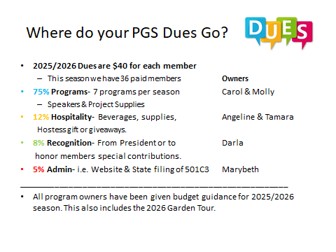
Membership: Carol was sick and unable to join us. Marybeth shared that as of today we have 37 paid members.
Garden Tour: Cathy gave updates on the May 17th Garden Tour.
- She shared the 5 Garden Tour Homes- SL and Grapevine
- The Sponsorship package is close to being completed. Sponsorship solicitations will begin in October.
- Cathy shared all the members and their roles in the tour.
- Next Garden Tour meeting will be in November. Cathy to send out an invite.

Grants: Kim Deras shared on behalf of Sian
- 20 Grant Letters and Applications have been sent out. PGS grant budget is $1000 for 2026. Grants are for new garden projects or garden maintenance.
- Deadline for Grant Applications is December 19th.

Hospitality: Angeline thanked Ashely and Marybeth for bringing refreshments.
- Angeline did a Giveaway of two adorable fall succulent gardens. Winners were: Bea and Kay
- Angeline also asked members to sign up for refreshments for future meetings. And passed around a signup sheet.

Other Business: Bea brought up two city topics:
- SL City Survey is out and our input is important. She suggested that we ask for SLPGS to be recognized along with other non-profits and be given the opportunity to have free meeting space at city buildings.
- VATRE- A current proposal to keep school funds in Southlake. Please vote YES!

Programs: Molly talked about our November Program “Dried Flower Art” at Diane’s home. She encouraged everyone to come!
- Molly introduced Betsey Marsh our speaker “Healing Gardens”
- It was a wonderful and thought provoking program.
- Betsey was so kind and donated her honorarium speaker fee to our Grants program!

Meeting Commenced: 10:45am
The program was held after the PGS meeting.

